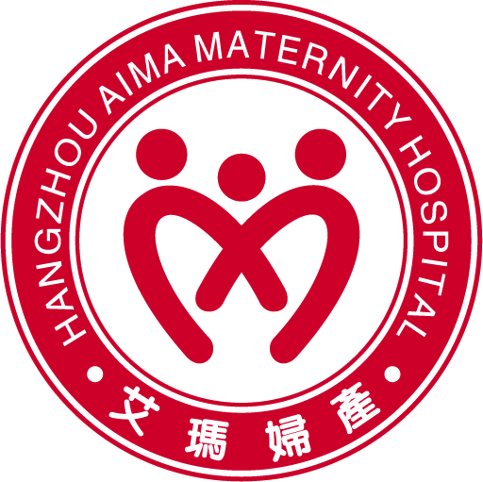
What to Bring to Hospital
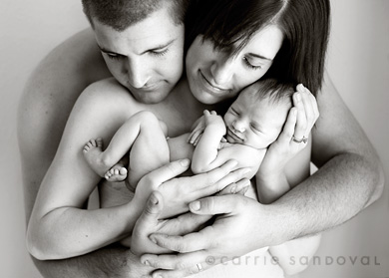

For Mum
Any medications you have been taking or may need during your stay
Maternity bras
Nighties (approx. 3)
Casual day clothes
Breast pads
Maternity pads
Toiletries
Cotton undies (quite a few)

For Baby
6 Grow suits
6 cotton singlets
2 pairs of mittens, booties
Baby wipes
Please note: Disposable nappies are supplied by the hospital
*For twins – increase baby requirements by two
For Partner
Change of clothes
Toothpaste/toothbrush and other toiletries
List of important phone numbers

Important Reminder
Please ensure you have organized a car restraint for taking your baby home with you at the end of your stay.

Luggage
Please keep this in mind when packing for your hospital stay. If you require a large suitcase, please ensure it has wheels to make transport easier. We will provide staff to assist you with luggage, but in the interest of the health and safety of our staff, Hangzhou Aima is moving towards a No Lift policy.

