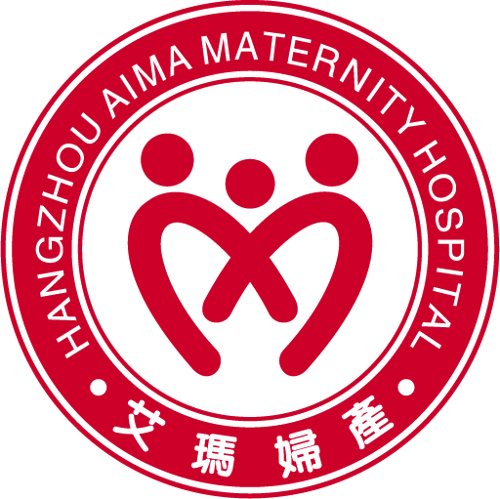
Frequently Asked Questions

How do I book into Hangzhou Aima Maternity Hospital when I find out I am pregnant?

Congratulations and welcome to Hangzhou Aima Maternity Hospital! You have made the right choice for making sure that you and your precious baby will receive the most qualified and experienced care available and will be in very safe hands during this exciting journey.

All you have to do to book into Hangzhou Aima is phone our International Medical Care Center on (0571) 5681 8818 during normal business hour (9:00 -17:00).

How do I book a tour of the hospital?

That’s easy. Please call (0571) 5681 8818 to make a booking. Tours are conducted 3pm on Weekends and 2.30pm on Fridays. We love meeting all our expectant parents and to help with any questions and/or concerns you may have about your stay with us.

How much will the hospital stay cost?

This will depend on whether or not you have health insurance and the level of cover you have.

There are also other costs associated with having a baby, such as your Obstetrician, Ultrasound, Pathology, Pediatrician and Anesthetist.

How do I book into Child Birth Education Classes and Breastfeeding classes?

The classes we holding currently are free Child Birth education class and open 2:30pm - 4:00pm on Saturdays. For Breastfeeding classes will be hold once per week. It’s available for breast-feeding mothers to come and receive advice and helps from the hospital’s internationally qualified Lactation Consultants.

Please phone (0571) 5681 8818 to booking your class, and we will update the class schedule and topic on Aima English website every week.

How many nights do I have to stay in hospital?

Although every birth is different, the usual length of stay is 4 nights (going home on Day 5) for a natural birth and 5 nights (going home on Day 6) for a planned caesarean section.
If you have had an emergency or a more complicated caesarean section you will stay for an extra day and go home on Day 7.

Have more questions?
For further information, please contact:
Vivien Li
Director of International Medical Care Centre
Email: vivien.lee@live.com.au Phone: (0571) 5681 8818

